SOCIAL STUDIES — 2004 (Set I—Outside Delhi)
Q. 1.* Describe the characteristics of temples of architecture of the Pallavas. 2
Q. 2.* Mention two main features of Mughal architecture during the period of Shahjahan. 2
Q. 3. What is resource planning? State any two stages of resource planning. 1+1=2
Q. 4. State four major uses of water. ½+4=2
Q. 5. What are the two types of metallic minerals? Give one example of each.1+1=2
Q. 6. How is climate the most important factor in soil formation? Explain two reasons. 1x2=2
Q. 7. Name any two north-eastern States of India having over 60 percent of forest cover. Give two reasons. 1+1=2
Q. 8. Compare the diagrams showing land use pattern of India and answer the questions that follow: 1+1=2
INDIA
LAND USE 1950-51 AND 1998-99
1950-51
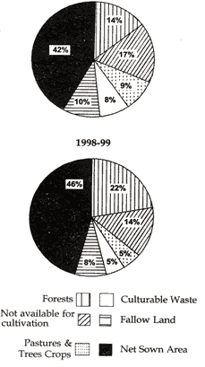
(8.1) Name the two categories under which the area in use has increased.
(8.2) Give at least one reason for this increase in these categories.
Note : The following question is for Blind Candidates only in lieu of Q. No. 8:
Why has land under pastures decreased in 1998-99 in comparison to 1950-51? Give two reasons.
Q. 9. Mention two main causes of price rise in India . 2
Q. 10. Explain two characteristics of capitalist or free market economy. 2
Q. 11. Mention any two steps taken to remove the social inequalities among the citizens belonging to weaker sections. 2
Q. 12. Explain two characteristics of terrorism. 2
Q. 13. Explain two principles of Panchsheel as agreed to by China and India in 1954. 2
Q.14.* Examine the contributions of Aligarh Movement in the reform of Muslim community. 4
Q.15. Examine the legal measures adopted by the British Government in the 19 century to improve the condition of Indian women. 4
Or
*How did the growth of Press and literature, during the nineteenth century help in the spread of new ideas. 4
Q. 16. Why is conservation of minerals essential? Explain any three methods of conservation of minerals. 1+3=4
Q. 17. What is poverty? Describe briefly any two poverty alleviation programmes.1+3=4
Q. I8. Explain structural and cyclical unemployment. Give one example of each.2+2=4
Q. 19 . "Planning in India derives its objectives and social premises from Directive Principles of State Policy." Justify the statement. 4
Q. 20. What were the aspirations of the Moderate Congress at its beginning? 6
Q. 21. "Indian road transportation is confronted with problems." Describe any six problems. 1x6=6
Q. 22. Explain any six features of subsistence farming. 1x6=6
Or
Why has Indian agriculture started a declining trend in food production? How can we overcome this problem? 3+3=6
Q. 23. Why is the iron and steel industry mainly located in north-eastern parts of the Indian Peninsula ? Explain any six reasons. 1x6=6
Q. 24. Describe positive aspects of the strategy of India 's economic development before 1991. 6
Or
Give the meaning of globalisation and describe the steps taken in this direction. 6
Q. 25. Explain how the Public Distribution System and fiscal measures help in controlling price rise. 6
Q. 26. Explain the role of health in human development and also explain the steps taken in this direction by the Government of India. 6
Or
Explain the main provisions of the 'Persons with Disability Act, 1995'. 6
Q. 27. (a) On the outline map of India provided to you, locate and name any two of the following: 2
(i) The place from where Gandhiji started his march to begin the Civil Disobedience Movement,
(ii) The place where he launched his 'Satyagraha' against the indigo planters, and
(iii) The place (session) where the Indian National Congress passed its resolution on Fundamental Rights and Economic Programme.
(b) On the outline map of India given below locate and label the features given below: 3
(i) Haldia Oil Refinery
(ii) Narora Nuclear Power Plant
(iii) Salem Iron and Steel Centre
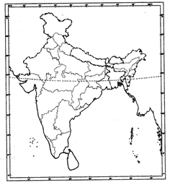
(c) Study the map of India given below and identify the features marked A, B and C and write their names correctly in the space provided. 3
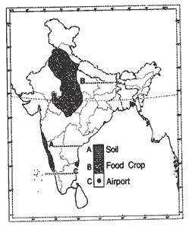
Note: The following question is for the Blind Candidates only in lieu of Q.No. 27.
Q. 27.1. List any two methods adopted by the 'Moderate' leaders of the Indian National Congress to put forward their demands. 2
27.2. Name the oil refineries located in Uttar Pradesh and Kerala. 1
27.3. Name the nuclear power stations located in Gujarat and Tamil Nadu. 1
27 . 4. Name the two iron and steel plants located in Karnataka. 1
27.5. Name the Software Technology Parks located in Uttar Pradesh and Orissa. 1
27.6. Name the two leading sugarcane producing States of India . 1
27.7. Name the two major ports located in Tamil Nadu. 1

